Advanced Artificial Intelligence
1. Generative and Probabilistic Models
1.1 Introduction: Overview of generative models and their importance in AI, Fundamentals of Probability theory and generative modeling, Introduction to GANs, VAEs and other generative models. Significance of generative models, Challenges with generative models.
1.2 Probabilistic Models: Gaussian Mixture Models(GMMs), Hidden Markov Models(HMMs), Bayesian Networks, Markov Random Field (MRFs), Probabilistic Graphical Model.
PAST QUESTIONS:
- Differentiate between Generative Adversarial Network and Variational Auto Encoder. (M25, M24)
- Explain Gaussian Mixture Models. (M25, M24)
- Explain Markov Random Field in detail. (M25)
- List and explain the challenges in Generative Models. (D24)
- Write a short note on Bayesian Network with suitable example. (D24)
- A patient goes to the doctor for a medical condition, the doctor suspects three diseases as the cause of the condition. The three diseases are D1, D2, D3, which are marginally independent from each other. There are four symptoms S1, S2, S3, S4 which the doctor wants to check for presence in order to find the most probable cause of the condition. The symptoms are conditionally dependent to the three diseases as follows: S1 depends only on D1, S2 depends on D1 and D2. S3 is depends on D1 and D3, whereas S4 depends only on D3. Assume all random variables are Boolean, they are either ‘true’ or ‘false’.
i. Draw the Bayesian network for this problem.
ii. Write the expression for the joint probability distribution as a product of conditional probabilities.
iii. What is the number of independent parameters required to describe this joint distribution? (M24)
- Explain Hidden Markov Models. (M24)

NOTES:

*Generative Model :-
A generative model is a type of machine learning model that aims to learn underlying patterns or distributions of data to generate new, similar data.
Generative models learn the data distribution of an input training set, to generate new data points similar to the initial training set. It means that these models can understand and replicate the nuances of your data.
From image generation to natural language understanding and synthesis, this Generative Model has a wide range of applications and is the basis of the latest generation of AI systems powered by large language models (LLMs).
Generative models learn the probability distribution P(X) of training data. They model how data is generated and can: • Generate new samples from the learned distribution • Estimate likelihood of data points • Capture underlying data patterns

*Significance :-
1. Data Generation: Create synthetic realistic data (images, text, audio)
2. Data Augmentation: Expand limited datasets
3. Anomaly Detection: Identify outliers by modeling normal distribution
4. Missing Data Imputation: Estimate missing values
5. Semi-supervised Learning: Learn from unlabeled data
6. Feature Learning: Extract meaningful representations Applications:
7. Image synthesis, style transfer, image-to-image translation
8. Text generation, music composition
9. Drug discovery, molecular generation
10. Data augmentation for imbalanced datasets

*Challenges :-
- Mode Collapse: Especially in GANs, models might fail to capture the full diversity of training data.
- Memory Limitations: Difficulty maintaining context in long, complex interactions.
- Computational Intensity: Training and running these models require massive, expensive computing resources.
- Hallucinations: Models can generate content that sounds plausible but is entirely incorrect or false.
- Quality Variance: Outputs can be inconsistent, irrelevant, or inappropriate.
- Token Constraints: Many models can only process a certain number of words (tokens) at once limiting their ability to handle long inputs or context-heavy tasks.

*GANs vs VAEs :-
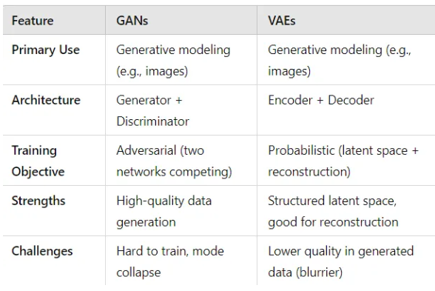
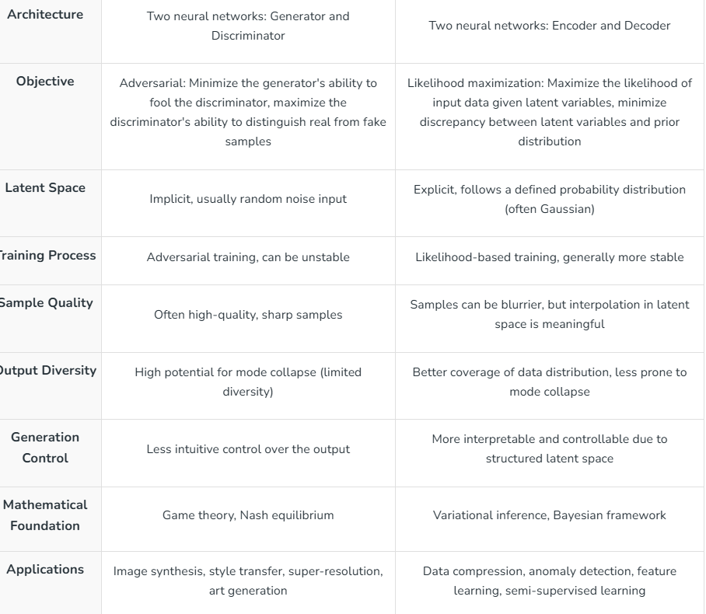
*GMMs :-
A Gaussian mixture model (GMM) is a probabilistic model that represents data as a combination of several Gaussian distributions which are also known as Normal distributions, each with its own mean and variance, weighted by a mixing coefficient. GMMs are commonly used for clustering and density estimation, since they can capture complex, multimodal distributions.
- Assigns each data point a probability of belonging to different clusters
- Can handle overlapping clusters effectively
- Uses mean and covariance to define cluster shape
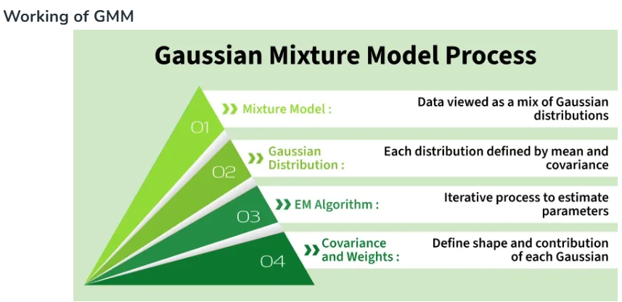
Algorithm:
Model Representation -
At its core, a GMM is a combination of several Gaussian components.
These components are defined by their mean vectors, covariance matrices, and weights, providing a comprehensive representation of data distributions.
The probability density function of a GMM is a sum of its components, each weighted accordingly.
Notation:
- K: Number of Gaussian components
- N: Number of data points
- D: Dimensionality of the data
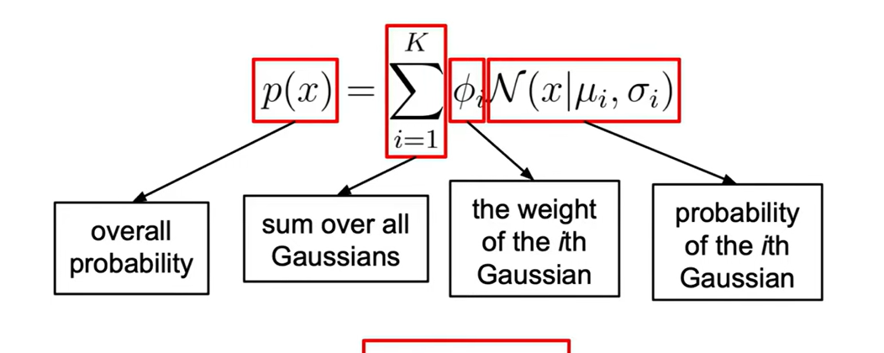
GMM Parameters:
- Means (μ): Center locations of Gaussian components.
- Covariance Matrices (Σ): Define the shape and spread of each component.
- Weights (π): Probability of selecting each component.
Model Training -
Training a GMM involves setting the parameters using available data. The Expectation-Maximization (EM) technique is often employed, alternating between the Expectation (E) and Maximization (M) steps until convergence.
Expectation-Maximization -
During the E step, the model calculates the probability of each data point belonging to each Gaussian component. The M step then adjusts the model’s parameters based on these probabilities.
Clustering and Density Estimation -
Post-training, GMMs cluster data points based on the highest posterior probability. They are also used for density estimation, assessing the probability density at any point in the feature space.
Applications:
- Anomaly Detection: Identifying unusual data patterns.
- Image Segmentation: Grouping pixels in images based on color or texture.
- Speech Recognition: Assisting in the recognition of phonemes in audio data.
- Handwriting Recognition: Simulating different handwriting styles.
- Customer Segmentation: Grouping customers with similar behaviors or preferences.
- Data Clustering: Finding natural groups in data.
- Computer Vision: Object detection and background removal.

*HMMs :-
When working with sequences of data, we often face situations where we can't directly see the important factors that influence the datasets. Hidden Markov Models (HMM) help solve this problem by predicting these hidden factors based on the observable data.
HMM is a statistical model that is used to describe the probabilistic relationship between a sequence of observations and a sequence of hidden states.
A Hidden Markov Model is a statistical model in which the system is assumed to follow a Markov process with hidden states. The model consists of transition probabilities, emission probabilities, and initial state probabilities, and is widely used for sequence prediction problems such as speech recognition and natural language processing.
Here are the fundamental components and concepts associated with Hidden Markov Models:
- States: An HMM models a system as a sequence of hidden states. These states represent underlying, unobservable conditions or situations. For instance, in speech recognition, the states might represent phonemes or words.
The internal unobservable states
Example: Rainy, Sunny in weather prediction.
Example: states = {Noun, Verb, Adjective}
- Observations: At each time step, the HMM emits an observation based on the current hidden state. These observations are what we can measure or see. In speech recognition, observations can be acoustic features like spectral information.
The visible outputs generated from hidden states.
Example: Umbrella, No umbrella.
Example: words in a sentence
- State Transition Probabilities: HMMs incorporate transition probabilities, which specify the likelihood of moving from one hidden state to another at each time step. These probabilities are typically organized as a transition matrix.
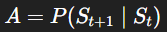
Probability of going from one hidden state to another
Rainy → Rainy = 0.7
Rainy → Sunny = 0.3
Example: P(Verb → Noun)
- Emission Probabilities: For each hidden state, there are associated emission probabilities. These probabilities determine the likelihood of emitting a particular observation when the system is in that state. Emission probabilities are typically represented as emission matrices or vectors.
Probability of a state generating a specific observation
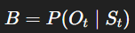
Example:
If Rainy → Umbrella = 0.9
If Sunny → Umbrella = 0.2
Example: P(“cat” | Noun)
- Initial State Probabilities: HMMs also have initial state probabilities, which specify the likelihood of starting in each hidden state at the beginning of the sequence.
Probability of starting in a particular state
Applications of HMM in AI
- Speech recognition
- Part-of-speech tagging in NLP
- Handwriting recognition
- Bioinformatics (DNA sequencing)
- Activity recognition

*Bayesian Network :-
A Bayesian network is a probabilistic graphical model that represents variables and their conditional dependencies using a directed acyclic graph (DAG).
Bayesian Belief Network is a graphical representation of different probabilistic relationships among random variables in a particular set. It is a classifier with no dependency on attributes i.e. it is condition independent. Due to its feature of joint probability, the probability in Bayesian Belief Network is derived, based on a condition — P(attribute/parent) i.e. probability of an attribute, true over parent attribute.
Bayesian Belief Network (BBN) is a graphical model that represents the probabilistic relationships among variables. It is used to handle uncertainty and make predictions or decisions based on probabilities.
- Graphical Representation: Variables are represented as nodes in a directed acyclic graph (DAG), and their dependencies are shown as edges.
Nodes – random variables
Edges – dependency/casual relationship
No cycles
Example:
Rain → Wet Grass ← Sprinkler
- Conditional Probabilities: Each node's probability depends on its parent nodes, expressed as $P(\text{Variable | Parent})$.
Examples:
$$P(Rain)$$
$$P(Sprinkler)$$
$$P(WetGrass∣Rain,Sprinkler)$$

- Probabilistic Model: Built from probability distributions, BBNs apply probability theory for tasks like prediction and anomaly detection.

Consider this example:
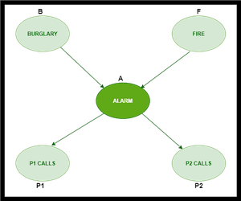
In the above figure, we have an alarm ‘A’ – a node, say installed in a house of a person ‘gfg’, which rings upon two probabilities i.e. burglary ‘B’ and fire ‘F’, which are – parent nodes of the alarm node. The alarm is the parent node of two probabilities P1 calls ‘P1’ & P2 calls ‘P2’ person nodes.
Upon the instance of burglary and fire, ‘P1’ and ‘P2’ call person ‘gfg’, respectively. But, there are few drawbacks in this case, as sometimes ‘P1’ may forget to call the person ‘gfg’, even after hearing the alarm, as he has a tendency to forget things, quick. Similarly, ‘P2’, sometimes fails to call the person ‘gfg’, as he is only able to hear the alarm, from a certain distance.
Do a sum* imp – watch videos, based on the sum solve the above example.

*MRFs :-
A Markov Random Field (MRF) is a probabilistic graphical model used to represent relationships among a set of random variables where the dependencies are undirected.
A MRFs is an undirected graph.
A MRF has a set of –
Nodes: Each corresponds to a variable or group of variables.
Edges: Edges connect variables that directly influence each other it represents relationships or dependencies between variables.
Cliques: Subset of nodes that are fully connected.
Do a sum* from YT.

